Design Task 3 – MTF 171
Gas Turbine Technology

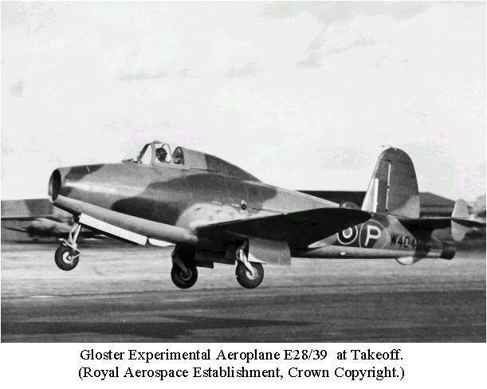

Off-design and altitude operation of the Frank Whittle W1 engine

Introduction
This design task, Task 3, focuses on carrying out the off-design calculations that Sir Frank Whittle once undertook as a preparatory work for the upcoming flight tests with the E28/39 experimental aircraft. The aircraft is depicted on the first page an below. The Gloster E28/39 could carry only 373 l of fuel, limiting the test flights to 30-40 minutes. Flights of up to 12800 m (42 000 ft) were made and Mach 0.82 was reached in a dive.

A schematic of the original engine installation is shown in the image below:
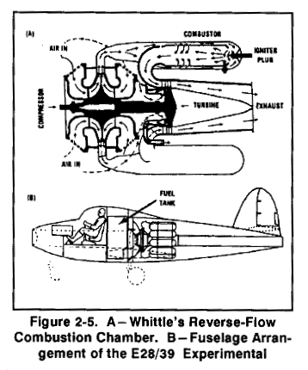

The previous tasks, Task 1 and Task 2 - i.e. the preliminary design of the engine and blade design of the axial turbine have given you considerable insight in the process of preliminary design of jet engines. This task, Task 3, will focus on estimating the off-design performance of the designed engine, i.e. the performance of the engine when the fuel flow is varied. Investigations will be undertaken both at ground conditions (Seal Level Static) as well as at altitude operation.

A procedure for calculating off-design performance of the turbojet engine is described in Chapter 8 in Cohen Rogers and Saravannamuttoo. The intention of this task is to follow the steps outlined in Fig. 8.6, thereby allowing a prediction of the performance of the engine for a large range of fuel flow settings.

General instructions for performing the task
For this task it is strongly recommended to work in the MATLAB environment, since some building blocks for the simulation task have already been completed and can be downloaded from the homepage (the starting kit). These routines are only distributed in MATLAB format. If you want to work with another programming environment you have to start by repeating this work.

Component characteristics – the starting kit
Since the information on the original W1 design given at the Cambridge web cite (http://www-g.eng.cam.ac.uk/125/achievements/whittle/whitt-r.htm) is limited, some further assumptions have to be made to make the set of performance data complete. Remember that Whittle’s company Power Jets Ltd., could not afford component testing, and performance characteristics for the turbine and compressor have therefore never existed. Consequently we need to model

- Compressor characteristic
- Turbine characteristic

based on some other sources. In addition to this, we also need Fig. 2-17 (C.R.S. page 70 [5th edition]) in MATLAB format. These three additional pieces of information will be given to you as a “starting kit” for the design task. See the zip-file called starting-kit at the course homepage.

How to use the starting kit

Compressor characteristic
The compressor characteristic that we will use is from a NASA radial test compressor [1]. The original characteristic has been scaled to agree with the design point of the W1 engine. The compressor characteristic is displayed below:
Figure 1 - Compressor characteristics (engine design point is indicated with a star)

The main program for simulating the off-design performance is odp.m (part of the starting kit). Your task is now to modify this file by adding the rest of the necessary off-design simulation code required to find the equilibrium running line of the engine (see task specification section).
As seen in Figure 1 above, the compressor map consists of eight rotational speed lines. Your task is thus to find the equilibrium running point for each of these lines. These eight points, when connected, then constitute the running line.

The line load_comp_char; in the odp.m file loads the compressor map into the computer memory (from the external file whittle_map.txt). This command must be executed before you can start to use the other commands described below. To find the surge and choke pressure for a certain rotational speed line i (i=1, 8) you type:

[rc_surge, rc_choke] = get_surge_and_choke(i)

For instance, if you type [rc_surge, rc_choke]=get_surge_and_choke(6) you should obtain:

r_surge = 4.72440940000000
r_choke = 3.33195080000000

To get data for a compressor operating point you type:

[mcorr1, etac, ncorr1] = get_compressor_operating_point(i,rc)

where rc must be a pressure ratio between the surge and choke pressure ratios. You select which rotational speed line to interpolate from by setting the index i (i=1, 8). The output is the corrected mass flow, m_{corr,1}, i.e.

$m_{\text{corr},1}=\frac{m\sqrt{θ_{1}}}{δ_{1}}=\frac{m\sqrt{\frac{T_{1}}{\text{288}\text{.}\text{15}}}}{\frac{P_{1}}{\text{101325}\text{.}0}}$

etac, i.e. the isentropic efficiency, and n_{corr,1} which is the corrected rotational speed, i.e. n/√θ. You can test this command by writing:

[mcorr1, etac, ncorr1]=get_compressor_operating_point(7,4.0)

You should then obtain:

eta = 0.72386187081580
mcorr1 = 11.80210927074805
ncorr1 = 17750

If rc is outside the allowed range for the selected running line, i.e. below the choking pressure ratio r_choke or above the surge pressure ratio r_surge, an error message will be printed and the execution will terminated. You can test this by for instance writing get_compressor_operating_point(6,5.0). You should then obtain:

??? Error using ==> get_compressor_operating_point
Compressor surge - requested rc too high

If you want to plot the compressor characteristic you can type: plot_comp_char;.This should generate the plot illustrated in Figure 1.

Turbine characteristic
The turbine characteristic is more straightforward to use. The mass flow characteristic is similar to the curve given in Fig. 8.3. The formula for the characteristic is:

$\frac{m\sqrt{T_{\text{03}}}}{P_{\text{03}}}=A_{3}X(γ_{g})\sqrt{1−{\left(\frac{\frac{r_{t^{}}}{r}−1}{r_{t^{}}−1}\right)}^{2}}$ if r_{t} < $r_{t^{}}$ ( $r_{t}=\frac{P_{\text{03}}}{P_{\text{04}}}$ )
$\frac{m\sqrt{T_{\text{03}}}}{P_{\text{03}}}=A_{3}X(γ_{g})$ if $r_{t}$ > $r_{t^{}}$
where, $X(γ_{g})=\sqrt{\frac{γ_{g}}{R}}{\left(\frac{γ_{g}+1}{2}\right)}^{−\frac{γ_{g}+1}{2\left(γ_{g}−1\right)}}$ , and$r_{t^{}}$ is the turbine choking pressure ratio (stagnation pressure ratio). $r_{t^{}}$is set equal to 2.15 for the Whittle turbine. Comparing this pressure ratio with the turbine pressure ratio determined in Design Task 1 will reveal if the turbine operates choked.

Use the equations above together with the mass flow, T₀₃ and P₀₃ from Design Task 1 to determine the turbine area A₃. Use this calculated area in your subsequent calculations.
To get data for a turbine operating point you type:

mcorr3 = get_turbine_operating_point(P03_P04,gamma_g,A3,R)

The command mcorr3 = get_turbine_operating_point(2.40, 1.333, 0.022, 287.0) should result in:

mcorr3 = 8.741769502975099e-004

You can plot the turbine characteristic by executing the command plot_turb_char(A3);. A sample is illustrated in below.
Figure 2 – turbine characteristics. Note that mcorr3 depends on the turbine area A3.

Fig. 2-17 in MATLAB format
To avoid tedious interpolations in Fig. 2-17 a MATLAB implementation for calculating the fuel air ratio for given t₀₂ and t₀₃ has been implemented. To perform a fuel air ratio calculation the following command should be used:

fa_vec = fminbnd('fa_err',0.0,0.0676,[],t02,t03,43200000.0)

For t02=482.0 and t03=1046.0 you should obtain the following:

fa_vec = 0.01451775026846

This routine serves two purposes. The first is to allow you to calculate fuel flow for different t02 and t03. The second is to illustrate how to use the fminbnd function by an example. Use the help command in MATLAB to find out more about the fminbnd function.

Specification of task
The task to be performed is to complete the odp.m program with the required physics in order to determine the engine running line. Follow the steps in Fig. 8.6. Note that you need information from section 8.5 to obtain the necessary equations for defining the nozzle characteristics.

To be successful the following steps are suggested:
- First balance the gas generator. Use fminbnd to determine the p₃/p₄ pressure ratio. Start with rotational speed line 7 and use design point data. This will allow you to check all the calculations since you can use data from Design Task 1.
- Balance engine for design rotational speed. This requires running one fminbnd call inside another. Make sure that the nozzle characteristic that you have coded works, before you put the system together. Note that you need A5 from Design Task 1.
- Balance engine for all rotational speeds.
- Calculate thrust and exhaust temperature. Compare with the trends that Whittle predicted.
- Calculate fuel flow using fminbnd and fa_err as discussed above to obtain SFC.

Note that since you are solving equations with a minimizer you need to use abs() on the error (see fa_err.m file). You are free to use any other solver, but I have only tested that the engine can be balanced using two nested fminbnd:s. This test was performed in MATLAB 6.5.

A recommended structure for the program is to have one file gasGenerator.m which is balanced/iterated in by a file turbojet.m which in turn is iterated in by the odp.m main program, i.e. two iteration loops as suggested in Fig. 8.6 in C.R.S.

Outline of report
- Plot the predicted exhaust temperature, thrust and SFC as a function of rotational speed. Compare it with the results that Whittle obtained.
- What is the thrust at the operating point that Frank Whittle envisioned for the aircraft
(500 mph at 30000 feet). Make use of the standard atmosphere and equations 3.10 and 3.11 for the intake. What is the turbine inlet temperature at altitude operation? What does this show about the thermal load for the turbine. Is the nozzle choked during flight? Why is this the case/not the case? Note that it is sufficient to study the operation at the design rotational speed line (i=7) for this sub-task.

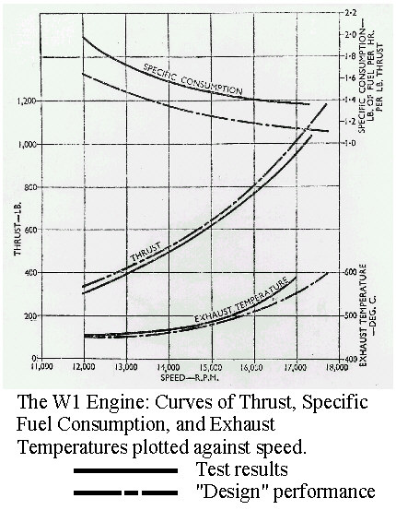
Figure 3 – the original Whittle performance curves.

Unit conversion table
1 inch | 0.0254 meter
1 pound force (lbf) | 4.448 Newton
1 pound mass (lbm) | 0.45359237 kg/s
1 mph | 0.4470 m/s
1 foot | 0.3048 m
Table 1 - unit conversion factors

References
[1] Klassens, H.A., Wood J.R. and Schuman L. F. “Experimental Performance of 16.1 Tip Diameter Sweptback Centrifugal Compressor Designed for a 6:1 Pressure Ratio”, NASA TMX-3552 1977

