MTF 171 – Gas turbine technology
Exam - 2006-03-04

Allowed exam aids:
- Any calculator allowed (no lap-top computers)

Unclear matters: 031-7721409, 0704-923339

Problem 1 (13 credits)
The Trent 60 is an aero-derivative engine derived from the Rolls-Royce Trent 800. As indicated in Fig. 1 below, the IP (intermediate pressure) and HP (high pressure) systems are left unchanged from the aero engine.

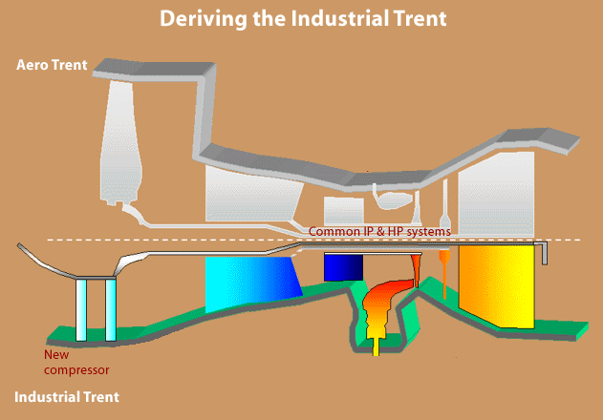
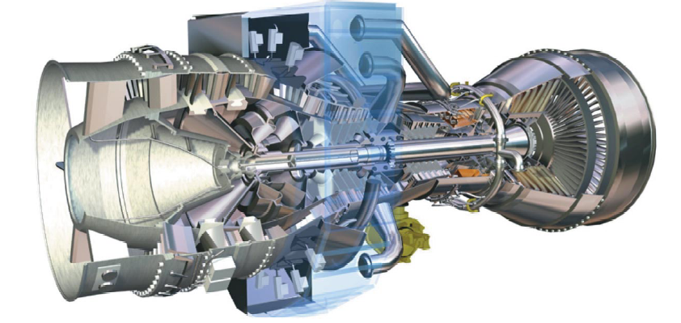
Fig. 1 - The Trent 60 aero derivative

For the Trent 800 typical values on performance are: FPR = 1.71, OPR = 40.8, BPR = 5.8, Mass flow = 1200 kg/s. Assuming realistic levels of turbomachinery efficiencies, engine technology and pressure losses, what power output could you expect for the aero derivative at standard sea level conditions. Neglect turbine cooling air effects. Assume the same pressure ratio and efficiency on the two LP (low pressure) compression systems.

The Trent 60 is known to be the highest power aero derivate available on the market. How does your computed level of power compare with what you know from large industrial gas turbines? What are typical changes introduced in aero-derivatives as compared to aero engines?

Problem 2 (10 credits)
The rotational speed on the LP system of the Trent 60 is typically 3000 rpm. The blade mean diameters of the two fan stages, see Fig. 2, are approximately 1620 mm. Estimate the pressure ratio on the two stage fan. Discard the presence of the IGV in your calculations.

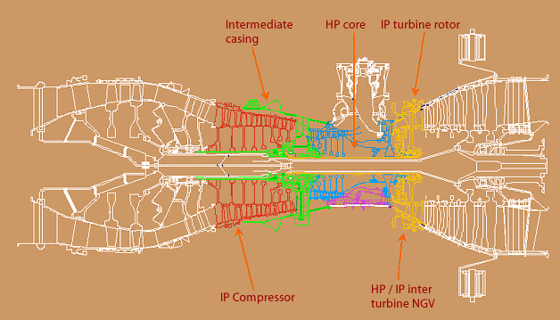
Two-stage fan
D_{m}
Fig. 2 - Cutaway of the Trent 60

What de Haller number do you compute for the stators and rotors at the mid? From inspecting the cutaway drawing, do you expect that the levels of the de Haller numbers that you have computed will lead to any problems?

Problem 3 (10 credits = 2+2+2+2+2)
The Trent 60 is provided with two combustor alternatives:

- DLE = Dry Low Emissions. This combustor type uses an eight cannular staged combustor.
- WLE = Wet Low Emissions.

Problem 3a (2p)
What does eight cannular combustor mean? Illustrate briefly?

Problem 3b (2p)
What does staged combustion mean? Illustrate briefly.

Problem 3c (2p)
In the staged combustor you described above, where do you find the primary and secondary zones in a staged combustor.

Problem 3d (2p)
The second type of combustor, the WLE, uses water to reduce NO_{x} emissions. Why does the use of water result in NO_{x} emission reduction?

Problem 3e (2p)
How does the water injection influence the performance of the engine?

Problem 4 (10 p)
In an ideal intercooled gas turbine cycle, see Fig. 3, the gas is compressed to a pressure ratio r_{c} according to:

$$r_{c}=\frac{P_{2}}{P_{1}}$$

The pressure ratio is equally divided between the two compression processes. Thus,
we have:

$$\frac{P_{2}}{P_{\text{16}}}=\frac{P_{\text{15}}}{P_{1}}$$

and the intercooling is carried out to the initial temperature, that is t₁₆=t₁.

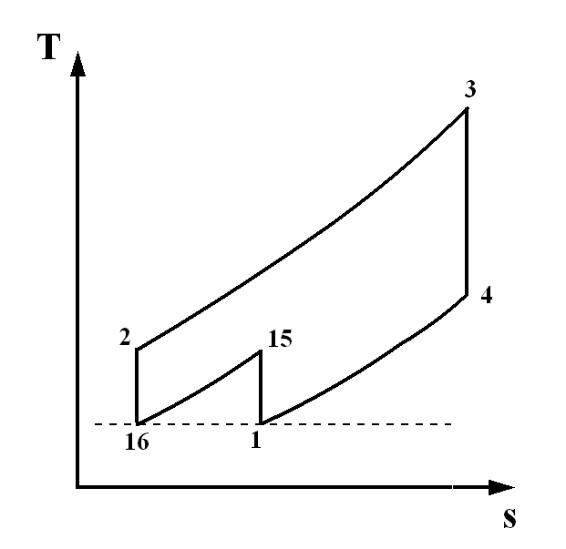
Fig. 3 - Intercool cycle

Assume that the engine temperature ratio t, defined as:

$$t=\frac{T_{3}}{T_{1}}$$

is fixed by material properties and cooling technology. In terms of the temperature ratio t, how should the pressure ratio r_{c} be selected to maximize power output?

Problem 5 (7 credits = 6+1)

Problem 5a (6 credits)
We have derived a relation for the radial variation of enthalpy according to:

$\frac{{\text{dh}}_{0}}{\text{dr}}=\frac{C_{w}^{2}}{r}+C_{a}\frac{{\text{dC}}_{a}}{\text{dr}}+C_{w}\frac{{\text{dC}}_{w}}{\text{dr}} (1)$

by equating inertia forces and pressure forces along a streamline. Use equation (1) to derive a design rule for blade angle variations from root to tip (the free vortex condition). State the required assumptions.

Problem 5b (1 credit)
Equation (1) above was obtained by studying a fluid element along a streamline assuming inviscid and axisymmetric conditions. Additionally, two simplifying assumptions were necessary to arrive at equation (1). State these two assumptions.

Problem 6 (10 credits)

Fig. 4 – Double sided impeller

During the course you have worked on the Whittle engine and in particular you carried out some preliminary calculation on the pressure rise that the radial compressor would deliver. Some of the design data were:

Double sided impeller
Mass flow = 11.79 kg/s
N = 17750 rpm
Tip diameter = 19 inch
Eye tip = 10.75 inch
Eye root = 5.5 inch
Number of blades = 29
Power input factor = 1.04
1 inch = 0.0254 meter
Standard sea level conditions

However, if you read the paper from where the design data was obtained carefully you may have observed that there was another mass flow stated for the engine, claiming that the engine mass flow would be 34 lb/s = 15.42 kg/s.

From what you know about radial compressor aerodynamics and compressibility effects make a statement about if this is likely to have been the case. Carry out calculations supporting your statement.

Good luck – Tomas

------------------------------------------------------------------------------------------------------
Grading:

Complete set of hand in tasks gives 10 bonus points.

0-23 point = Failed
24-35 = Grade 3
36-47 = Grade 4
48-60 = Grade 5

Some useful expressions
$T_{\text{02}}−T_{\text{01}}=\frac{T_{\text{01}}}{η_{c}}\left({\left(\frac{P_{\text{02}}}{P_{\text{01}}}\right)}^{\frac{γ−1}{γ}}−1\right) (2\text{.}\text{11})$ $T_{\text{03}}−T_{\text{04}}=T_{\text{03}}η_{t}\left(1−{\left(\frac{P_{\text{04}}}{P_{\text{03}}}\right)}^{\frac{γ−1}{γ}}\right) (2\text{.}\text{12})$
$\frac{T_{0}}{T}=1+\frac{C^{2}}{2c_{p}T}=1+\frac{γ−1}{2}M^{2}$ (2.7) $\frac{P_{0}}{P}={\left(\frac{T_{0}}{T}\right)}^{\frac{γ}{γ−1}}$ (2.8)
$\frac{T_{\text{02}}}{T_{\text{01}}}={\left(\frac{P_{\text{02}}}{P_{\text{01}}}\right)}^{\frac{1}{η_{c,∞}}\frac{γ−1}{γ}} (2\text{.}\text{15})$ $\frac{T_{\text{03}}}{T_{\text{04}}}={\left(\frac{P_{\text{03}}}{P_{\text{04}}}\right)}^{η_{t,∞}\frac{γ−1}{γ}} (2\text{.}\text{17})$

$T_{\text{04}}−T_{5}=η_{j}T_{\text{04}}\left(1−{\left(\frac{P_{5}}{P_{\text{04}}}\right)}^{\frac{γ−1}{γ}}\right) (3\text{.}\text{12})$ $\frac{P_{\text{04}}}{P_{c}}=\frac{1}{{\left[1−\frac{1}{η_{j}}\left(\frac{γ−1}{γ+1}\right)\right]}^{\frac{γ}{γ−1}}} (3\text{.}\text{14})$
$w_{\text{12}}=\left[\text{adiabatic}\right]=c_{p,\text{12}}\left(T_{\text{02}}−T_{\text{01}}\right)$

$P_{\text{03}}=P_{\text{02}}\left(1−\frac{{Δp}_{b}}{p_{\text{02}}}−\frac{{Δp}_{\text{ha}}}{P_{\text{02}}}\right)$ $m=\text{ρπ}r_{t^{2}}\left(1−{\left(\frac{r_{r}}{r_{t}}\right)}^{2}\right)C_{a}$ $\begin{aligned}c_{p}\left(T_{\text{02}}−T_{\text{01}}\right)= {UΔC}_{w} ={\text{UC}}_{a}\left(\text{tan}β_{1}−\text{tan}β_{2}\right) (5\text{.}5) \\ c_{p}\left(T_{\text{02}}−T_{\text{03}}\right)={UΔC}_{w}={\text{UC}}_{a}\left(\text{tan}β_{2}+\text{tan}β_{3}\right) (7\text{.}3)\end{aligned}$

$\frac{m\sqrt{{\text{RT}}_{0}}}{P_{0}A}=\sqrt{γ}M{\left(1+\frac{γ−1}{2}M^{2}\right)}^{−\frac{(γ+1)}{2(γ−1)}}=Χ(γ,M)$
$D≈\frac{V_{\text{max}}−V_{2}}{V_{1}}≈1−\frac{V_{2}}{V_{1}}+\frac{{ΔC}_{w}}{2V_{1}}⋅\frac{s}{c}$
$\frac{V_{2}}{V_{1}}≥0\text{.}\text{72}$
$Λ=\frac{{ΔT}_{\text{static}, \text{rotor}}}{{ΔT}_{\text{stage}}}$,
$$Λ=\frac{C_{a}}{2U}\left(\text{tan}β_{1}+\text{tan}β_{2}\right)$$
$$\text{F }=m\left(C_{j}−C_{a}\right)+A_{j}\left(p_{j}−p_{a}\right)$$
$\begin{aligned}c_{\text{pa}}=\text{1005}\text{ J/kg , }γ_{a}=1\text{.}\text{400} \\ c_{\text{pg}}=\text{1148}\text{ J/kg , }γ_{g}=1\text{.}\text{333} \\ R=\text{287}\text{ J/kg K, } Q_{\text{net,}ρ}=\text{43100} {\text{kj}}/{\text{kg}}\end{aligned}$
$σ=1−\frac{0\text{.}\text{63}⋅π}{n}$ (Stanitz formula – slip factor)

