MTF 171 – Gas turbine technology
Exam - 2005-03-12

Allowed exam aids:
- Any calculator allowed (no lap-top computers)

Unclear matters: 031-7721409, 0704-923339

Problem 1 (6 credits)
After studying the design tasks you are quite knowledgeable about the Whittle turbojet engine. A contemporary German engine, the Junkers Jumo 004, is shown below:

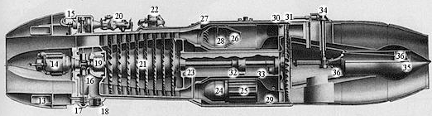
Fig. 1 The Junkers Jumo 004
Some basic engine data are:

Frontal diameter | 0.760 m
Air mass flow | 21.2 kg/s
Pressure ratio | 3.1
RPM | 8700
Turbine inlet temperature | 1048 K
Hub tip ratio | 0.6
Table 1 - Basic data on the Junkers Jumo 004

By using the data in Table 1, estimate the thrust that the engine delivered!

Problem 2 (5+7=12 credits)
Your knowledge about axial compressor design tells you that the eight stage compressor, item 21 in Fig. 1, must be very lightly loaded since it only delivers a pressure ratio of 3.1. The goal with this problem is to come up with a design change that will allow a radical reduction in the number of stages.

Problem 2a (5 credits)
Start the analysis by calculating the de Haller number and the tip Mach number for the first stage rotor. Assume that the stage temperature rise is equally distributed on the eight stages and that you can use the relationships derived for constant mid radius and constant axial velocity without modification (assume a work done factor λ = 1.0).

Problem 2b (7 credits)
Use the information you have obtained about the de Haller number and the tip Mach number as input to the analysis of the design problem. Use what you know about design ranges for modern axial compressors. Come up with a suggestion on how the compressor should be re-designed to reduce the number of stages. Your suggested changes should allow at least three stages to be removed. Comment on the difficulties that your design will face. Will aerodynamic and/or mechanical problems be likely?

Problem 3 (10+2=12 credits)
Problem 3a (10 credits)

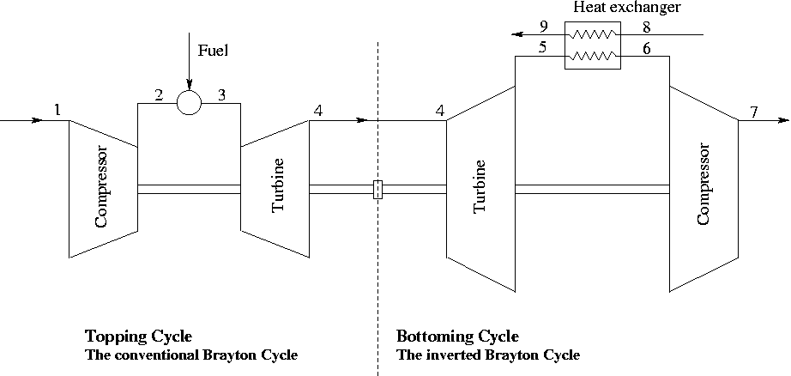
Fig. 2 Combined conventional Brayton Cycle and inverted Brayton cycle.

In Fig. 2 above, an alternative gas turbine configuration is suggested. A conventional gas turbine cycle is followed by an inverted gas turbine cycle. The inverted gas turbine cycle recovers some of the heat available in the exhaust gases from the topping cycle. The topping cycle is the part of the gas turbine cycle to the left of the dashed line in Fig. 2. The inverted cycle (to the right of the dashed line) starts with a turbine expansion, a heat exchanger is used to cool the turbine exhaust gases and the gas is finally compressed to ambient pressure by the compressor. Evaluate a possible efficiency for this combined plant. Use realistic assumptions on component technology. No optimization of the cycle is required.

Note that the expression for the heat exchanger effectiveness as stated in the “some useful expressions sheet”, applies to station numbering used in a standard heat exchange cycle.

Problem 3b (2 credits)
Give two other examples of bottoming cycles recovering some of the heat available in the exhaust gases from a topping conventional Brayton cycle. Explain, briefly, the principle of operation for the suggested cycles.

Problem 4 (10 credits)
Show that the specific net power produced by the bottoming cycle in Fig. 2 can be written as:

$$\begin{aligned}w=\frac{c_{\text{pg}}\left(α−1\right)}{{\text{αη}}_{C}}\left[{αT}_{4}\left(η_{\text{HE}}−1\right)\left(1−η_{T}\right)+η_{T}T_{4}\left(η_{C}+η_{\text{HE}}−1\right)−{\text{αη}}_{\text{HE}}T_{8}\right] \text{where} \\ α={\left(\frac{P_{4}}{P_{5}}\right)}^{\frac{γ_{g}−1}{γ_{g}}}\end{aligned}$$

Neglect mechanical losses and pressure losses in the burner. Note that you must keep the heat exchanger and isentropic turbomachinery efficiencies throughout the calculations to obtain the result.

How should the pressure ratio over the bottoming turbine be selected, to obtain maximum power output from the bottoming cycle (the topping cycle remains fixed)? You may set η_{HE}=1.0 to analysis this maximization problem.

Problem 5 (6 credits)
What is:

- Creep
- Erosion
- Corrosion

What governs these three deterioration mechanisms? How do they arise and where in the engine?

Problem 6 (3+1+4=8 credits)
- When carrying out preliminary jet engine design, it is important take the carousel effect into account, to assess how changes to the engine affect changes to the aircraft system. Explain the term “carousel effect” and how the term arises. (3 points)
- The performance of a modern turbofan engine is frequently stated in terms of OPR, BPR and cruise SFC. What are typical values on such parameters for modern engines? (1 point)
- Draw the T-S diagram for an intercooled process. What impact on cycle efficiency and power output does intercooling have (ideal cycles). Do you know of any recently built intercooled engines? What was the application for that engine? (4 points)

Problem 7 (6 credits)
In design task 3, performance simulation of the Whittle W1 turbojet, you are asked to make a statement about the operation of the nozzle. At take-off (operating at design speed), the nozzle pressure ratio is approximately 1.577 and thus the nozzle is operating unchoked. At 500 mph (223.5 m/s) and 30000 feet (9144 m), the nozzle pressure ratio is 2.16, thus a 37% increase in nozzle pressure ratio is observed. What is the cause of this increase in pressure ratio? Could you have predicted the 37% increase by a simple calculation, or do you predict a slightly different value? In that case, what is the cause for the difference?

Good luck – Tomas

----------------------------------------------------------------------------------------------------------------------------
Grading:

Complete set of hand in tasks gives 10 bonus points.

0-23 point = Failed
24-35 = Grade 3
36-47 = Grade 4
48-60 = Grade 5

Some useful expressions
$T_{\text{02}}−T_{\text{01}}=\frac{T_{\text{01}}}{η_{c}}\left({\left(\frac{P_{\text{02}}}{P_{\text{01}}}\right)}^{\frac{γ−1}{γ}}−1\right) (2\text{.}\text{11})$ $T_{\text{03}}−T_{\text{04}}=T_{\text{03}}η_{t}\left(1−{\left(\frac{P_{\text{04}}}{P_{\text{03}}}\right)}^{\frac{γ−1}{γ}}\right) (2\text{.}\text{12})$
$\frac{T_{0}}{T}=1+\frac{C^{2}}{2c_{p}T}=1+\frac{γ−1}{2}M^{2}$ (2.7) $\frac{P_{0}}{P}={\left(\frac{T_{0}}{T}\right)}^{\frac{γ}{γ−1}}$ (2.8)
$\frac{T_{\text{02}}}{T_{\text{01}}}={\left(\frac{P_{\text{02}}}{P_{\text{01}}}\right)}^{\frac{1}{η_{c,∞}}\frac{γ−1}{γ}} (2\text{.}\text{15})$ $\frac{T_{\text{03}}}{T_{\text{04}}}={\left(\frac{P_{\text{03}}}{P_{\text{04}}}\right)}^{η_{t,∞}\frac{γ−1}{γ}} (2\text{.}\text{17})$

$\frac{P_{\text{01}}}{P_{a}}={\left(1+η_{i}\frac{C_{a}^{2}}{2c_{p}T_{a}}\right)}^{\frac{γ_{a}}{γ_{a}−1}} (3\text{.}\text{10}b)$ $\frac{P_{\text{04}}}{P_{c}}=\frac{1}{{\left[1−\frac{1}{η_{j}}\left(\frac{γ−1}{γ+1}\right)\right]}^{\frac{γ}{γ−1}}} (3\text{.}\text{14})$
$w_{\text{12}}=\left[\text{adiabatic}\right]=c_{p,\text{12}}\left(T_{\text{02}}−T_{\text{01}}\right)$ $P_{\text{03}}=P_{\text{02}}\left(1−\frac{{Δp}_{b}}{p_{\text{02}}}−\frac{{Δp}_{\text{ha}}}{P_{\text{02}}}\right)$ $\begin{aligned}c_{p}\left(T_{\text{02}}−T_{\text{01}}\right)= {UΔC}_{w} ={\text{UC}}_{a}\left(\text{tan}β_{1}−\text{tan}β_{2}\right) (5\text{.}5) \\ c_{p}\left(T_{\text{02}}−T_{\text{03}}\right)={UΔC}_{w}={\text{UC}}_{a}\left(\text{tan}β_{2}+\text{tan}β_{3}\right) (7\text{.}3)\end{aligned}$

$\frac{m\sqrt{{\text{RT}}_{0}}}{P_{0}A}=\sqrt{γ}M{\left(1+\frac{γ−1}{2}M^{2}\right)}^{−\frac{(γ+1)}{2(γ−1)}}=Χ(γ,M)$ $m=\text{ρπ}r_{t^{2}}\left(1−{\left(\frac{r_{r}}{r_{t}}\right)}^{2}\right)C_{a}$
$D≈\frac{V_{\text{max}}−V_{2}}{V_{1}}≈1−\frac{V_{2}}{V_{1}}+\frac{{ΔC}_{w}}{2V_{1}}⋅\frac{s}{c}$ $\frac{V_{2}}{V_{1}}≥0\text{.}\text{72}$
$Λ=\frac{{ΔT}_{\text{static}, \text{rotor}}}{{ΔT}_{\text{stage}}}$, $η=\frac{w_{N}}{f⋅Q_{\text{net,}ρ}}$
$\begin{aligned}c_{\text{pa}}=\text{1005}\text{ J/kg , }γ_{a}=1\text{.}\text{400} \\ c_{\text{pg}}=\text{1148}\text{ J/kg , }γ_{g}=1\text{.}\text{333} \\ R=\text{287}\text{ J/kg K, } Q_{\text{net,}ρ}=\text{43100} {\text{kj}}/{\text{kg}}\end{aligned}$ $\text{F }=m\left(C_{j}−C_{a}\right)+A_{j}\left(p_{j}−p_{a}\right)$
$σ=1−\frac{0\text{.}\text{63}⋅π}{n}$ (Stanitz formula – slip factor)

