Problem 1 - 10 points

The Kashin was the first naval vessel to be power with gas turbines and was commissioned in 1962. The engine configuration used four gas turbines (single-shaft engines) to propel the ship configured to drive two propellers over two (reversible) gear boxes as illustrated below.

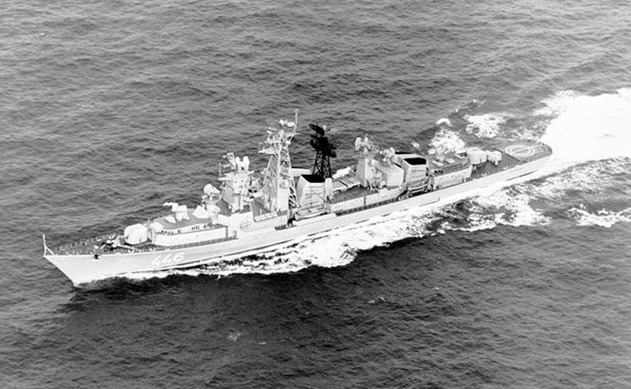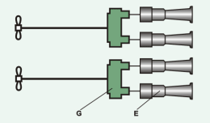

The cruise speed was 37-38 knots and the four gas turbines delivered around 96,000 shp in total (1 shp = 0.746 kW). The turbine material was probably conventionally cast alloy operating uncooled (except for blade root and disc cooling). Carry out a design point calculation for one of the gas turbines. Assume realistic levels on component efficiencies (in particular on the turbine inlet temperature).

Problem 2 - 10 points – NOTE: This type of problem is no longer possible for the exam. From year 2005, questions related to chapter 8 and chapter 9 will only relate to knowledge needed for design task 3 (turbojet performance).

After showing interest in the design of the gas turbines and contacting the original Russian design team (by now all retired), you receive the original compressor and propeller maps. This was found acceptable since most of the units are now scrapped. The propeller map is depicted below and the compressor map is given on the next page. They tell you that the engine had trouble at part speed. Around 92.9% of the design rotational speed surges were frequent as the engines degraded over time. The design point is indicated in the figure as a cross occurring at n=150 rps. Note that it is the mass flow and the mechanical speed, not the corrected mass flow and the corrected rotational speed, which are given in the compressor map (η=isentropic efficiency, π=compressor pressure ratio).

Figure 1 - propeller map
The turbine area (stator vane throat area) has been determined to be A = 0.130 m² and the polytropic efficiency in the operating point can be assumed to be 87%. Assume that the turbine operates choked and neglect losses in the gear box. Remember how the gas turbines are configured (see Problem 1).

Find the location of the operating point in the compressor map below. Comment on the surge problems that the Russians have experienced. Suggest some methods to alleviate this problem. How do you think that the engine was started?
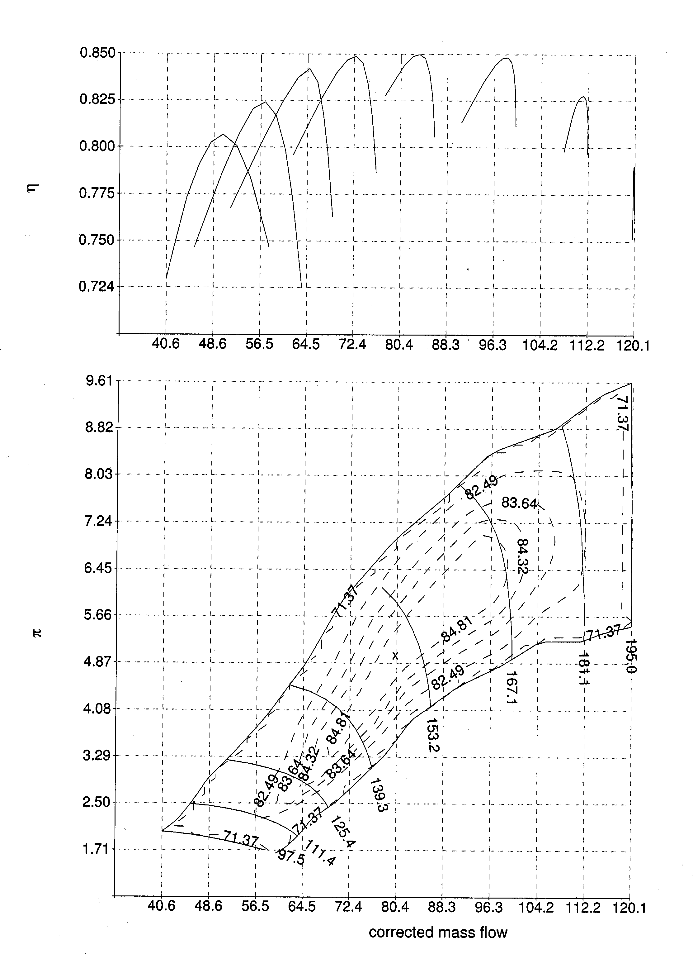
Figure 2 - Kashin compressor maps

Problem 3 (4+6 points)

By now you are almost perceived as an old colleague by the retired design team. The current operators of the vessel want to modernize the engines by introducing an intercooling scheme to deal with the poor part load efficiency of the engine. They have heard that intercooling is an efficient method to improve the performance of naval gas turbine engines due to the ease by which cooling water may be obtained. The retired design team claim that the operators have failed to learn their gas turbine theory properly. Since you seem like a nice guy the operators direct the question directly to you.

Problem 3a (4 points)
Comment on how an intercooling scheme would influence the cycle parameters (such as efficiency and power output). Just indicate the trends with some illustrative graphs. You do not need to carry out any calculations.

Problem 3b (6 points)
Derive the optimal pressure ratio for which to divide the compressor pressure ratio assuming that you are trying to maximize power output. Assume that the available cooling water will have the same temperature as the ambient air.

Problem 4 (6+4 points)

Problem 4a (6 points)
Derive an expression for the stage temperature rise as a function of the rotor blade angles. Clearly state the required assumptions for the calculations.
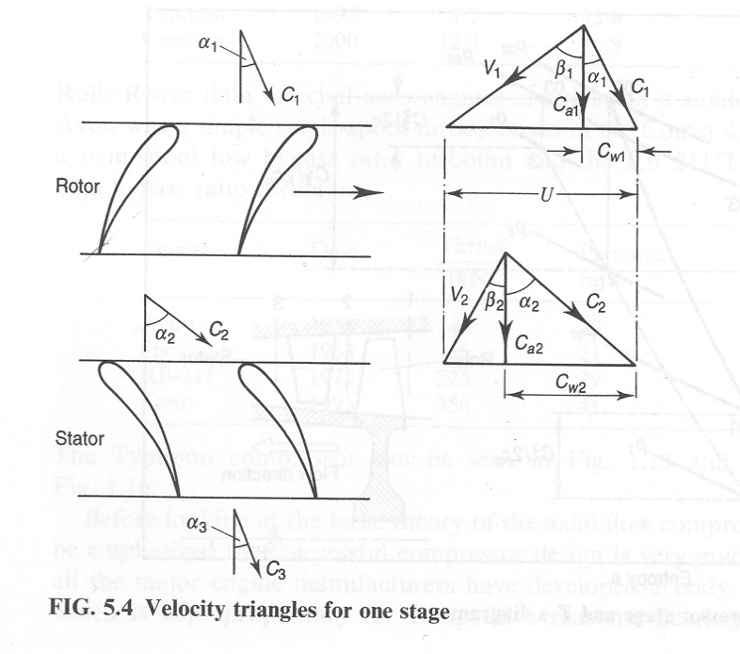

Problem 4b (4 points)
Define the degree of reaction and the de Haller number. What are these numbers used for. Do you know of any other parameters related to the preliminary design of compressor blades?
Problem 5 (2+2+4+2+2=12 points)

5a (2 point)

Define propulsive efficiency. What does it quantify. A particularly simple expression can be derived relating the aircraft velocity and jet velocity to the efficiency. State this expression. If you can derive it you get an extra point (the maximum on problem five as a whole is still 12 points)

5b (2 points)

Annular combustors are lighter and incur smaller combustion pressure losses than traditional can or can-annular types. State three disadvantages with annular combustors

5c (2+2 points)

What are the three main pollutants produced by gas turbines. Which is the most severe and has had most impact on the gas turbine development during the last two three decades? The book states three main techniques to deal with this most severe pollutant. Give a very short description of these three methods

5d (2 points)

Which are two main sources of noise? Characterize the two types. How are these two types related to turbojet versus high-bypass ratio turbofan cycles?

5e (2 points)

Explain the term rotating stall. Describe the mechanism by which the stall cell is being rotated.

Problem 6 (8 points)

Derive the X-function, i.e. the form of the continuity equation relating stagnation properties to the Mach number and specific heat ratio gamma, according to the formula below:

$\frac{m\sqrt{{\text{RT}}_{0}}}{P_{0}A}=\sqrt{γ}M{\left(1+\frac{γ−1}{2}M^{2}\right)}^{−\frac{(γ+1)}{2(γ−1)}}=Χ(γ,M)$

Start with the continuity equation. Recall that:
$\frac{T_{0}}{T}=1+\frac{γ−1}{2}⋅M^{2}$

Good luck - Tomas
----------------------------------------------------------------------------------------------------------------------------

Grading:

Complete set of hand in tasks gives 10 bonus points.

0-23 point = Failed
24-35 = Grade 3
36-47 = Grade 4
48-60 = Grade 5

Some useful expressions:
$T_{\text{03}}−T_{\text{04}}=T_{\text{03}}η_{t}\left(1−{\left(\frac{P_{\text{04}}}{P_{\text{03}}}\right)}^{\frac{γ−1}{γ}}\right) (2\text{.}\text{12})$
$\frac{T_{\text{03}}}{T_{\text{04}}}={\left(\frac{P_{\text{03}}}{P_{\text{04}}}\right)}^{η_{t,∞}\frac{γ−1}{γ}} (2\text{.}\text{17})$$T_{\text{02}}−T_{\text{01}}=\frac{T_{\text{01}}}{η_{c}}\left({\left(\frac{P_{\text{02}}}{P_{\text{01}}}\right)}^{\frac{γ−1}{γ}}−1\right) (2\text{.}\text{11})$
$\frac{T_{\text{02}}}{T_{\text{01}}}={\left(\frac{P_{\text{02}}}{P_{\text{01}}}\right)}^{\frac{1}{η_{c,∞}}\frac{γ−1}{γ}} (2\text{.}\text{15})$$w_{\text{12}}=\left[\text{adiabatic}\right]=c_{p,\text{12}}\left(T_{\text{02}}−T_{\text{01}}\right)$
$P_{\text{03}}=P_{\text{02}}\left(1−\frac{{Δp}_{b}}{p_{\text{02}}}−\frac{{Δp}_{\text{ha}}}{P_{\text{02}}}\right)$$\begin{aligned}c_{\text{pa}}=\text{1005}\text{ J/kg , }γ_{a}=1\text{.}\text{400} \\ c_{\text{pg}}=\text{1148}\text{ J/kg , }γ_{g}=1\text{.}\text{333} \\ R=\text{287}\text{ J/kg K}\end{aligned}$$\frac{P_{\text{04}}}{P_{c}}=\frac{1}{\left[1−\frac{1}{η_{j}}\left(\frac{γ−1}{γ+1}\right)\right]} (3\text{.}\text{14})$$\text{F }=m\left(C_{j}−C_{a}\right)+A_{j}\left(p_{j}−p_{a}\right)$$\frac{T_{0}}{T}=1+\frac{C^{2}}{2c_{p}T}=1+\frac{γ−1}{2}M^{2}$
$\frac{m\sqrt{{\text{RT}}_{0}}}{P_{0}A}=\sqrt{γ}M{\left(1+\frac{γ−1}{2}M^{2}\right)}^{−\frac{(γ+1)}{2(γ−1)}}=Χ(γ,M)$$T_{\text{02}}−T_{\text{01}}=\frac{{\text{UC}}_{a}}{c_{p}}\left(\text{tan}β_{1}−\text{tan}β_{2}\right)$$\frac{V_{2}}{V_{1}}≥0\text{.}\text{72}$$D≈\frac{V_{\text{max}}−V_{2}}{V_{1}}≈1−\frac{V_{2}}{V_{1}}+\frac{{ΔC}_{w}}{2V_{1}}⋅\frac{s}{c}$$$m=\text{ρπ}r_{t^{2}}\left(1−{\left(\frac{r_{r}}{r_{t}}\right)}^{2}\right)C_{a}$$

