Design Task 2 – MTF 171
Gas Turbine Technology

Preliminary design of the W1 turbine
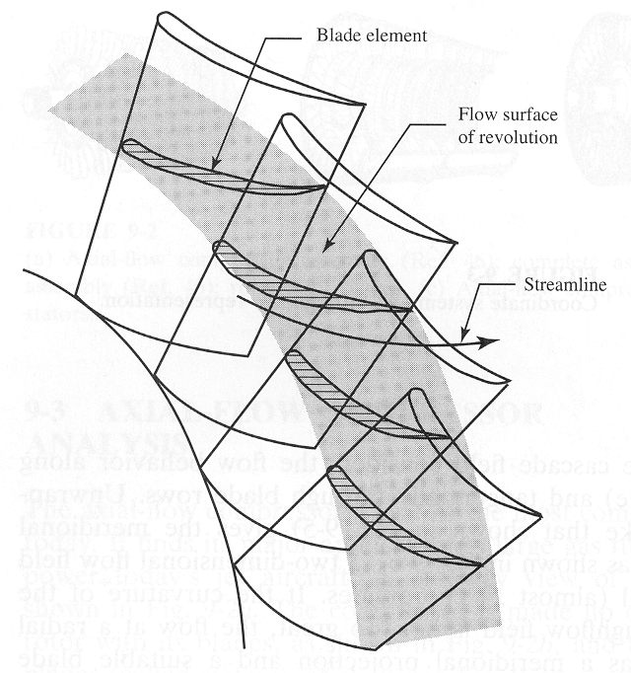

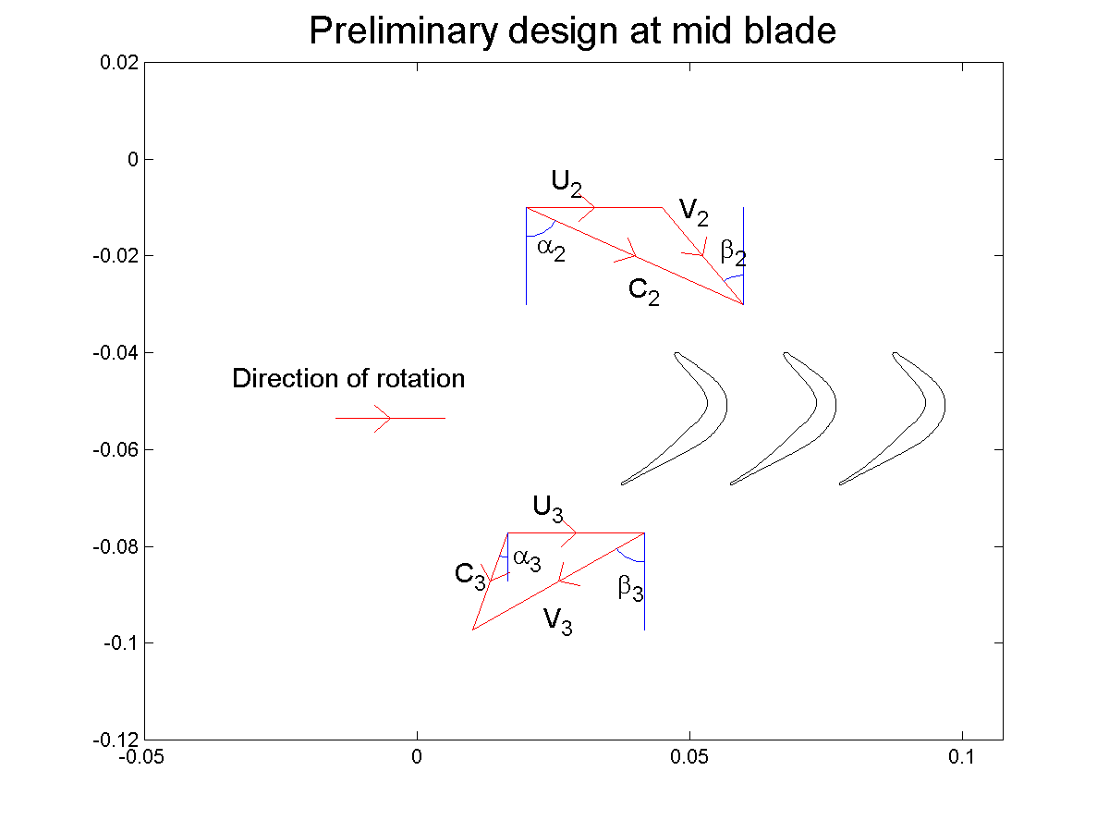

Introduction
This design task, Task 2, focuses on carrying out the necessary preliminary design calculations that Frank Whittle, later Sir Frank Whittle, once undertook to design the axial turbine component of the W1 aircraft engine. The W1 engine was used to power the first English aircraft propelled by jet power.

A schematic of the original engine installation is shown in the image below:
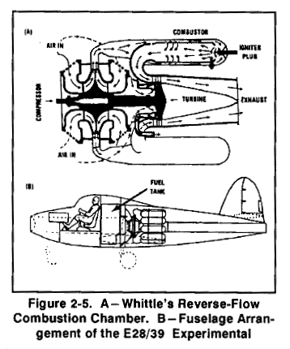

The preliminary design of the axial turbine requires knowledge from Chapter 7.

The previous task, Task 1 - i.e. the preliminary design of the engine, will give you boundary conditions for the turbine design. The upcoming task, Task 3, will focus on estimating the off-design performance of the engine, i.e. the performance for reduced fuel flow at ground condition as well as the engine operation at altitude.

General instructions for performing the task
The goal of this task is to carry out a preliminary design of an axial turbine at the blade mid, within the range of design recommendations given in Chapter 7. Systematic variations in turbine parameters, such as the turbine flow coefficient, φ, or the exit flow air angle, α₃, will most likely be needed to fulfill the requirements on root degree of reaction, nozzle (stator vane) pressure ratio and rotor root relative blade Mach number. Consequently, the manual process of hand calculation will then be much too time consuming.

It is advisable to make the modeling in a programming language/script language. I would recommend any of the following:

- MATLAB - the most straightforward choice.
- Java - take the opportunity to repeat some programming skills?
- C++ - if you master it (little guidance can be given)
- Fortran 90/Fortran 77 - if you plan to write your thesis on gas turbine technology issues, this may be a chance to warm up.
- C - if you master it (little guidance can be given)
- Other language - completely unsupported but allowed.

Assumptions regarding component losses and modeling
To successfully complete the task several pieces of information have to be put together. You must make reasonable assumptions on:

- Turbine blade loading ψ (this can be computed from your available data) – do you get a realistic value?
- Flow coefficient φ
- Outlet swirl angle α₃
- Assume a constant mid radius design

Turbine inlet and outlet conditions, as well as turbine efficiency was set during the solution of the first design task. Use these values together with data from the Meher-Homji paper attached to the first design task.

Make use of the nozzle (stator vane) and rotor flow coefficients:

$\begin{aligned}λ_{N}=\frac{T_{2}−T_{2}^{'}}{C_{2}^{2}2c_{p}} \\ λ_{R}=\frac{T_{3}−T_{3}^{''}}{V_{2}^{2}2c_{p}}\end{aligned}$

Assume that the rotor flow coefficient is twice as large as the nozzle flow coefficient (due to tip-leakage losses). Make sure that these assumptions are in agreement with the overall efficiency of the turbine. Note that the static conditions at the nozzle exit together with the nozzle inlet stagnation conditions can be used to calculate a nozzle efficiency. This efficiency can be used to determine a choking pressure ratio.

Design goal
The design goal is to obtain a set of blade angles that will fulfill the conditions of your engine design as well as to a give a satisfactory performance. To make sure that your design operates successfully check:

- Nozzle pressure ratio (should not exceed choking with more than 10%).
- The relative Mach number in the root of the rotor should not exceed 0.75
- Check that you have a positive reaction in the root assuming that you are designing your blade using the free vortex condition
- Try to minimize the amount of swirl that the turbine produces, i.e. to keep the outlet swirl angle α₃ minimal. You will find that a certain amount of exit swirl will have to be accepted.

Outline of report
Write a complete description of your modeling assumptions with motivation (when you think your assumptions require further justification). Make some additional comments on the following:

- Does the turbine nozzle operate choked/unchoked. What is the calculated nozzle efficiency? What is the critical pressure ratio for this efficiency?
- Draw a schematic of the turbine stage, illustrating the turbine nozzle and rotor designs (in the blade mid) as well as the annulus dimensions.
- What are the blade angles in the root of the rotor?

