Design Task 1 – MTF 171 Gas Turbine Technology

Preliminary design of the W1 Whittle Engine

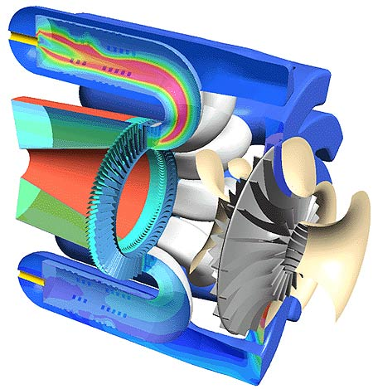

Whittle type aircraft engine

Introduction
This design task, Task 1, focuses on carrying out the necessary preliminary design calculations that Frank Whittle, later Sir Frank Whittle, once undertook to design the W1 aircraft engine. The W1 was used to power the first English aircraft propelled by jet power.

A schematic of the original engine installation is shown in the image below:
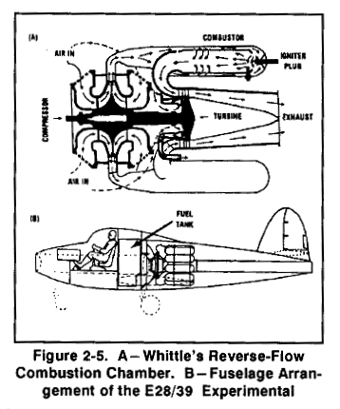

The preliminary design of the engine requires knowledge from Chapter 1-3 (in particular Chapter 3). The preliminary design of the radial compressor is based on material presented in Chapter 4.

Later tasks, i.e. Task 2 and Task 3, will focus on the aerodynamic design of the turbine as well as performance of the engine at take-off and altitude conditions.

General instructions for performing the task
Since the goal of this task is to model the engine thrust within 2% and the nozzle stagnation exit temperature, i.e. exhaust temperature, within 1% of the values stated in the text below, hand calculation is not recommended. Variation in component loss parameters will most likely be needed to tune the computed thrust and nozzle exit temperatures to the specified data. Consequently, the manual process will then be much too time consuming.

It is advisable to make the modeling in a programming language/script language. I would recommend any of the following:

- MATLAB - the most straightforward choice.
- Java - take the opportunity to repeat some programming skills?
- C++ - if you master it (little guidance can be given)
- Fortran 90/Fortran 77 - if you plan to write your thesis on gas turbine technology issues, this may be a chance to warm up.
- C - if you master it (little guidance can be given)
- Other language - completely unsupported but allowed.

Assumptions regarding component losses and modeling
To successfully complete the task several assumptions related to engine component losses have to be made. All modeling techniques have been described during lectures but the values on the loss parameters have to be found by you!!! However, the paper attached at the end of this PM gives several pieces of information on the W1 development program such as:

- Turbine efficiency.
- Engine mass flow.
- Upper limit on compressor efficiency. Note that the value stated in the abstract was not attained for the W1 design, but only for later improvements of the engine.
- Design point rotational speed.
- Diameter of radial compressor impeller.

You are supposed to compute the temperature rise of the radial compressor based on the methods explained in Chapter 4. Use the Stanitz formula to compute the slip factor and assume a reasonable value on the power input factor. An approximate value on T₀₃ can be found in the diagram below:
You are supposed to use the

Some of these modeling assumptions have been described during lectures, other may be found in the book. To make the set of data complete a number of guidelines are given below:

- To make a complete match

Modeling goal
To assess the modeling success you should make a comparison between the results you obtain and the results predicted by Whittle. Based on reasonable assumptions on losses (as given in the course), data presented in the attached paper and the "Figure 5.5" above, you should be able to model the thrust within 2% and the turbine exit temperature T₀₄ within 1%. The nominal condition, at sea level, is (as obtained from the Figure):

Thrust | 1200 lbf (see unit conversion table below)
Exhaust temperature (stagnation) | 600 °C
Table 1 - problem specification.
To achieve this agreement some variation in compressor efficiency and turbine inlet temperature is allowed! Standard loss parameter assumptions should be made according to the book except for the value of the burner pressure drop which should be assumed to be as high as 10%.
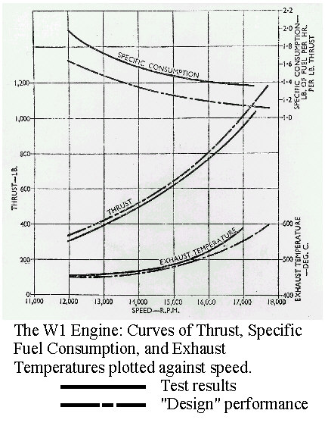

Outline of report
Write a complete description of your modeling assumptions with motivation (when you think your assumptions require further justification). Make some additional comments on the following:

- Does the nozzle operate choked/unchoked. What do you think will be the case at altitude (this will be studied in Design Task 3). You do not have to make any calculations in this task, only comment on the possibilities and the mechanisms involved.
- Where do you think the greatest modeling uncertainties are? Compare a 1% variation in compressor efficiency, turbine efficiency, burner pressure drop and turbine inlet temperature on thrust and turbine exit temperature.
- What is the difference in the stagnation temperature at the turbine outlet and nozzle outlet?
- Plot stagnation temperature and stagnation pressure variations versus the five different stations throughout the engine.

Unit conversion
Since Sir Frank Whittle worked with british (or so called imperial units) a table for unit conversion may be useful to have at hand:

1 inch | 0.0254 meter
1 pound force (lbf) | 4.448 Newton
1 pound mass (lbm) | 0.45359237 kg/s
Table 2 - unit conversion factors

